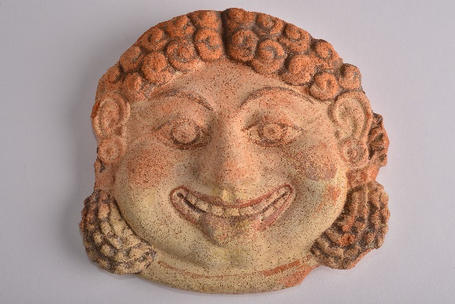 | An antefix covered the end of the tiles on the roof of a Greek temple. There would be a row of antefixes on each side of the temple roof. The Gorgon was thought to be apotropaic (protective).  This Gorgon has two rows of tight curls above the forehead and behind the ears, wide eyes and sticks its tongue out.  It is made of clay in a mould and then painted after firing. | Terracotta Gorgon antefix from Sicily  Shefton Collection, Great North Museum (inventory number 574)  c.500 BC  Height 16.4 cm  Case 1

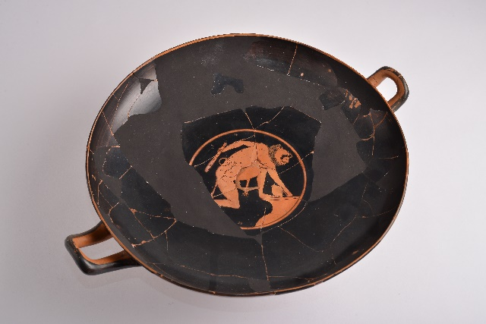 | In the inside of this drinking cup Herakles, wearing the lionskin, dips an oinochoe (jug) into a huge pithos (storage jar) of wine in Pholos' cave He holds a club in one hand and places his right foot on the edge of the pithos. Pholos was a centaur who offered Herakles a drink of wine however the neighbouring centaurs smelt the wine and attacked. Herakles killed most of them with his arrows. | Athenian red-figure cup  Shefton Collection, Great North Museum (inventory number 202)  525-500 BC  Diameter 32.3 cm  Case 1

